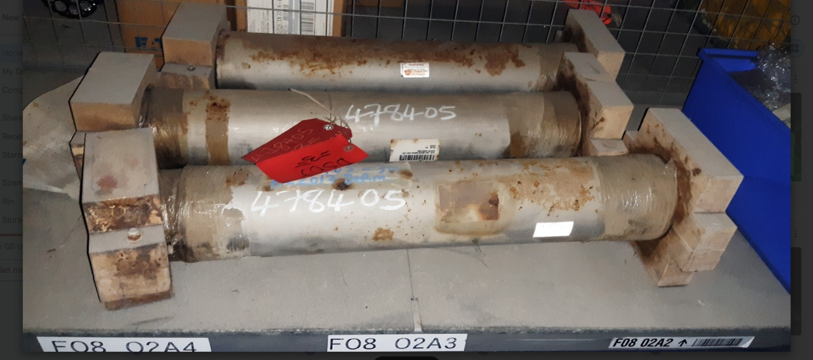

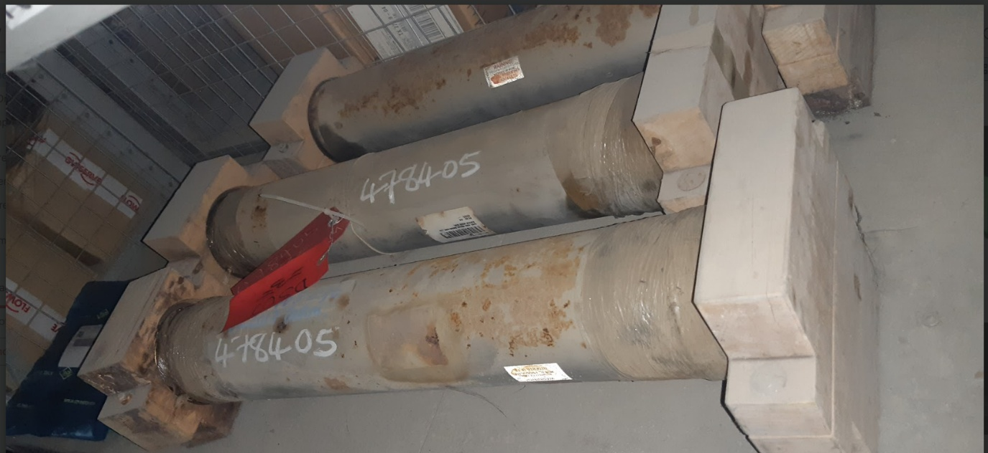

MAT NO 478405 CASE,GAS BURNER,3-19/32"ID,5"OD,28-1/8"L

